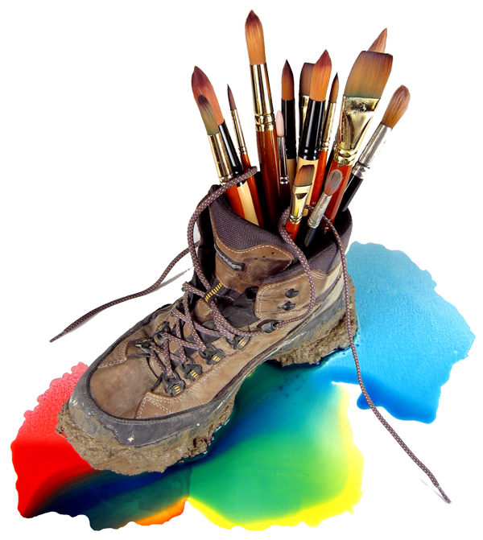

PRESS RELEASE

Contact: Marlene Spetz
Gary Spetz Studio
(406) 209-8230
marlene@spetz.com
www.spetz.com/pressroom

WATERCOLOR ON WATER

(Lakeside, MT, September 9th, 2014)

Montana watercolor artist and Public Television host, Gary Spetz, has signed an agreement with Holland America Line to create a series of Watercolor On Water painting workshops on select cruises, beginning in early 2015. The artist/host of the “learn to paint” series, Painting Wild Places, and the two travel series, Watercolor Quest and Color World (all distributed nationally by American Public Television), will intermix the two program genres, for this project. While “at sea,” Spetz will conduct live watercolor painting classes. And while “at port,” he will lead his groups on “composition port walks.”

These workshops are designed for all skill levels—employing the artist’s methodical step-by-step painting methods—as depicted on his Public Television series.

The 2015 workshop-cruises will embark to the Caribbean and Alaska. A Mediterranean workshop-cruise is being planned for 2016.

Gary Spetz is a host/producer of 98 lifestyle episodes in the “how to paint” and “travel” genres. He is a “signature member” of the National Watercolor Society.

For more information, please visit: www.spetz.com

